Create a resource group by using name , location and tags through PowerShell or azure portal

**PowerShell commands:**

**Account-connect:**

Connect-AzAccount

**Resource group creation:**

New-AzResourceGroup -Name webappkey -Location eastus -tag @{'resources'='web app and key vault'}

Get-AzResourceGroup -ResourceGroupName webappkey

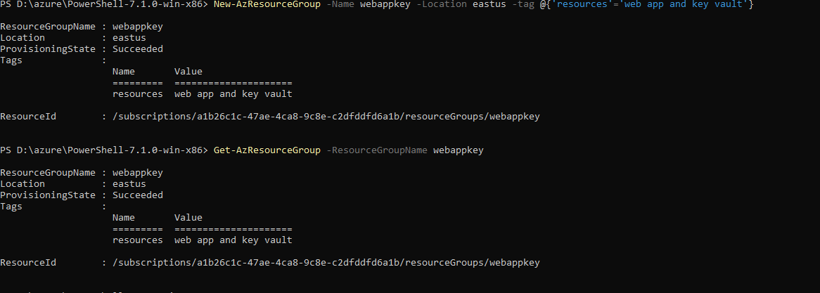

**Keyvault:**

To create a key vault use below command.

New-AzKeyVault -Name keyvault2021test -ResourceGroupName webappkey -Location eastus -EnabledForDeployment -EnabledForTemplateDeployment -Tag @{'resource'='key vault'}

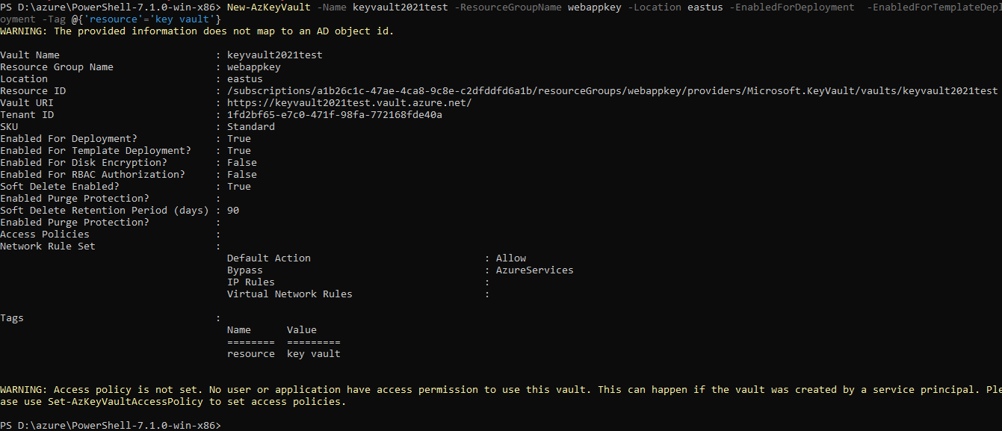

Next step, we have to add access policy for web app to access the key vaults and certs.

PS D:\azure\PowerShell-7.1.0-win-x86> Get-AzADServicePrincipal -DisplayNameBeginsWith "Microsoft Azure App"

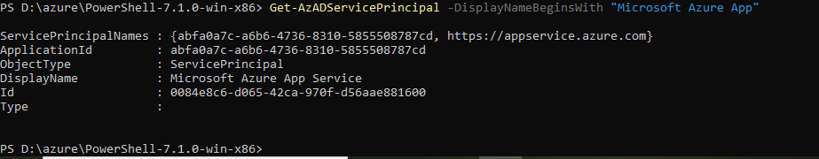

We can provide access policy using the object id for any app , user and groups

PS D:\azure\PowerShell-7.1.0-win-x86> Get-AzADServicePrincipal -DisplayNameBeginsWith "Microsoft Azure App"

ServicePrincipalNames : {abfa0a7c-a6b6-4736-8310-5855508787cd, https://appservice.azure.com}

ApplicationId : abfa0a7c-a6b6-4736-8310-5855508787cd

ObjectType : ServicePrincipal

DisplayName : Microsoft Azure App Service

Id : 0084e8c6-d065-42ca-970f-d56aae881600

Type :

PS D:\azure\PowerShell-7.1.0-win-x86> Set-AzKeyVaultAccessPolicy -VaultName keyvault2021test -ObjectId 0084e8c6-d065-42ca-970f-d56aae881600 -PermissionsToSecrets all -PermissionsToKeys all -PermissionsToCertificates all

Add certificate :

Below forbidden issue occurs because of access policy issue. So the user have access to create cert under keyvault. After added access policy we are able to create certs and keys

PS D:\azure\PowerShell-7.1.0-win-x86> $Policy = New-AzKeyVaultCertificatePolicy -SecretContentType "application/x-pkcs12" -SubjectName "CN=trailcert.com" -IssuerName "Self" -ValidityInMonths 6 -ReuseKeyOnRenewal

PS D:\azure\PowerShell-7.1.0-win-x86> Add-AzKeyVaultCertificate -VaultName keyvault2021test -Name "keyvault" -CertificatePolicy $Policy

Add-AzKeyVaultCertificate: Operation returned an invalid status code 'Forbidden'

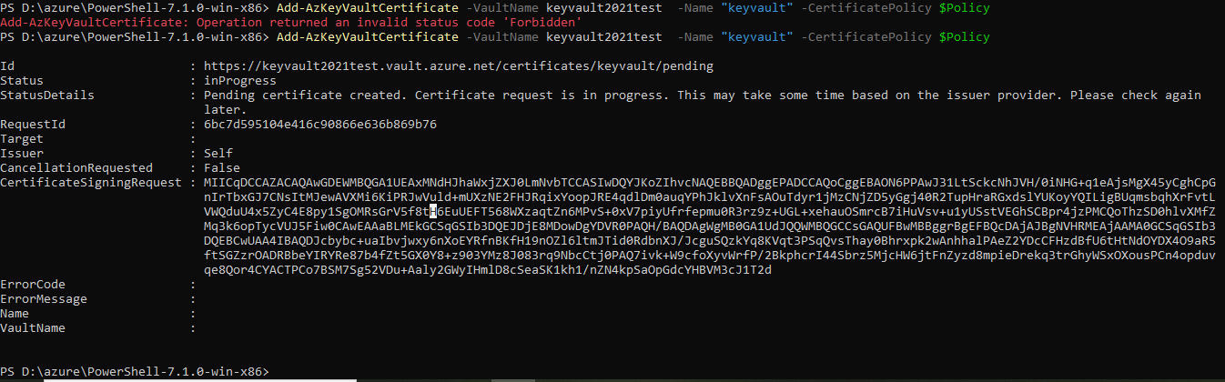

Get-AzKeyVaultCertificateOperation -VaultName keyvault2021test -Name "keyvault"

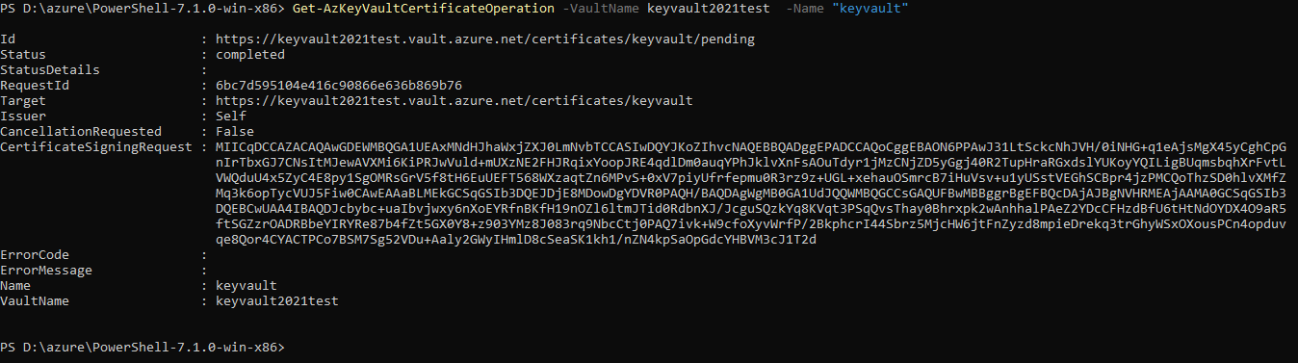

We can get the csr details by using above command and we can create pem or p12 file with that csr content and private key

PS D:\azure\PowerShell-7.1.0-win-x86> Get-AzKeyVaultCertificate -VaultName keyvault2021test -Name "keyvault"

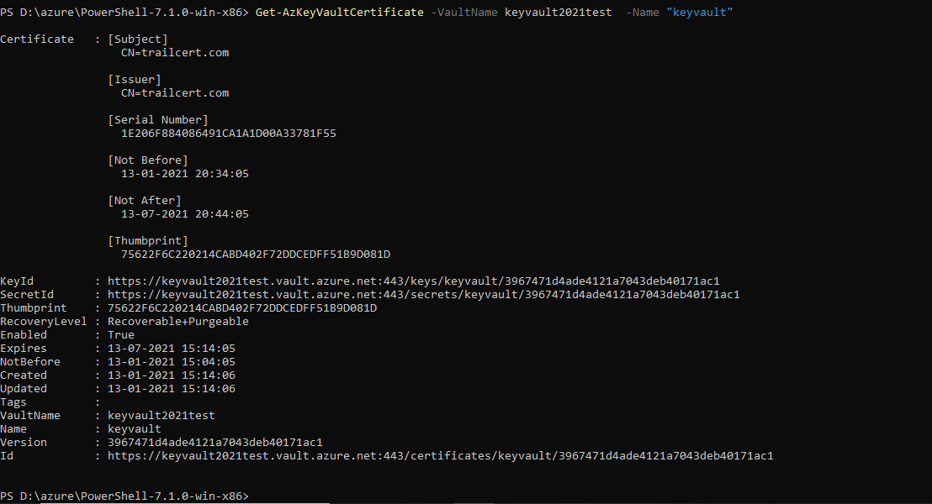

**Create a web app via Arm template:**

PS D:\azure\PowerShell-7.1.0-win-x86> New-AzResourceGroupDeployment -Name webapp -ResourceGroupName webappkey -TemplateFile "D:\azchlg\web app with key vault\prereqs\prereq.azuredeploy.json" -TemplateParameterFile "D:\azchlg\web app with key vault\prereqs\prereq.azuredeploy.parameters.json"

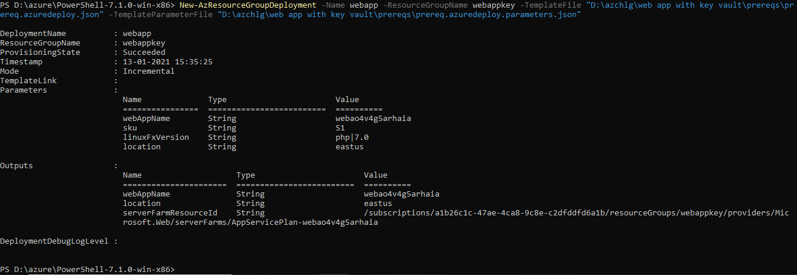

After web app creation we need to collect few details from existing app and key vault to make a connection.

**Parameters:**

"existingServerFarmId": Existing App Service Plan resource id that contains the App Service being updated

Example:

"value": "/subscriptions/a1b26c1c-47ae-4ca8-9c8e-c2dfddfd6a1b/resourceGroups/webapp/providers/Microsoft.Web/serverfarms/AppServicePlan-webcec7ditetyqtg"

"existingWebAppName": Existing App name to use for creating SSL binding. This App should have the hostname assigned as a custom domain

Example:

"value": " webao4v4g5arhaia"

},

"certificateName": certificate resource name

Example:

"value": "keyvault"

"existingKeyVaultId": Existing Key Vault resource Id with an access policy to allow Microsoft.Web RP to read Key Vault secrets

Example:

"value": "/subscriptions/a1b26c1c-47ae-4ca8-9c8e-c2dfddfd6a1b/resourceGroups/webapp/providers/Microsoft.KeyVault/vaults/keyvaulttrail1995"

"existingKeyVaultSecretName": Key Vault Secret that contains a PFX certificate

Example:

"value": "keyvault"

"hostname": Custom hostname for creating SSL binding. This hostname should already be assigned to the Web App

To create custom domain via powershell use below commands.

Note: For free account we cannot able to create custom domains

Set-AzAppServicePlan -Name $webappname -ResourceGroupName $webappname `

-Tier Shared

# Add a custom domain name to the web app.

$fqdn="<Replace with your custom domain name>"

Set-AzWebApp -Name $webappname -ResourceGroupName $webappname `

-HostNames @($fqdn,"$webappname.azurewebsites.net")

After updated all the parameter values in json file. We can able to link the key vault and webapp

**Deploy arm template with locally stored json files:**

New-AzResourceGroupDeployment -Name webapp1 -ResourceGroupName webappkey -TemplateFile "D:\azchlg\web app with key vault\azuredeploy.json" -TemplateParameterFile "D:\azchlg\web app with key vault\azuredeploy.parameters.json"